**Standard Deviation vs Standard Error: What’s the Difference?**

Twins from Different Universes



Photo by [Martin Sanchez](https://unsplash.com/@martinsanchez?utm_source=medium&utm_medium=referral) on [Unsplash](https://unsplash.com/?utm_source=medium&utm_medium=referral)

Standard Deviation and Standard Error are two statistical concepts that often cause confusion. Do they have the same interpretations or they are meant to represent something totally different? We’ll discuss more in this post.

**What is Standard Deviation (SD)?**

The **standard deviation** measures the **variability**(aka, the **spread**) of data points around the **mean**in a given dataset. In other words, it tells us, on average, how far each data point is away from the mean.

**Population Standard Deviation**

In the real world, we’re interested in estimating a certain characteristic in a **population**. Standard deviation is anexample of these characteristics.

When you have **ALL** the data points from a population, you can compute the **TRUE**value of the population standard deviation using the following formula.

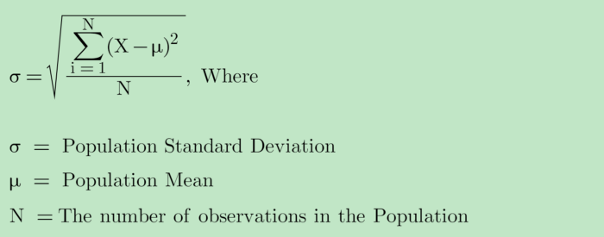

Image by author

**Sample Standard Deviation**

Oftentimes, it is difficult to collect all the data points from the population due to time, financial, or technical limitations. For example, if we would like to compute the **TRUE** standard deviation of household income in Los Angeles, we would need to get income from all the households in Los Angeles, which is almost impossible to do.

Instead, we can collect random samples from the population and make inferences about the population standard deviation using **Sample Standard Deviation.**The formula for sample standard deviation is

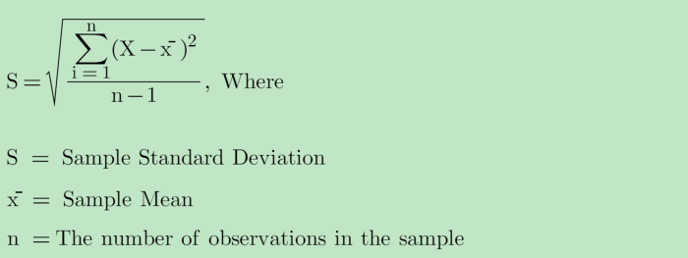

Image by author

**Why use n-1 for sample standard deviation?**

You will notice that we are using the sample mean (x̄) instead of the population mean (μ) for the sample standard deviation because we don’t know anything about the population mean. x̄ is a reasonable estimate for μ.

Therefore, any value X in the sample dataset would be closer to x̄ than to μ. The numerator in the sample standard deviation would get artificially smaller than it is supposed to be. As a result, the sample standard deviation would be **underestimated**.

To correct this **bias**in the sample standard deviation, we would use **“n-1” instead of “n” (**aka, **Bessel’s correction**) for sample standard deviation**.**

Using n-1 would make the sample standard deviation larger than otherwise using n. Therefore, we have a less biased estimate of the population standard deviation, giving us a conservative estimate of variability.

**What is Standard Error (SE)?**

Before we discuss the Standard Error, let’s first get familiar with the concepts of **Sample Distribution** and **Sampling Distribution**.

**Sample Distribution vs Sampling Distribution**

The **sample distribution** is simply the **data distribution** of the sample which is randomly taken from the population.

For example, we ask 100 random people in Los Angeles what their incomes are. The sample distribution describes the **ACTUAL**income distribution in these 100 people.

But what is Sampling Distribution?

The**sampling distribution** is the **distribution of the sample statistic** (e.g., the sample mean, sample variance, sample standard deviation, and sample proportion) over many samples drawn from the same population (i.e., **repeated sampling**).

For example, we ask 100 random people in Los Angeles what their incomes are. Then compute the average income. We repeat this 1000 times, then we have 1000 different average incomes. The distribution of these 1000 average incomes is called the sampling distribution.

*Therefore,****sample distribution****is the distribution of the****sample data****while****sampling distribution****is the distribution of the****sample statistic.***

*The concept is****standard error****is relevant to the sampling distribution, NOT the sample distribution.*

*The****Standard Error****is a metric that describes the****variability of a statistic****in the****sampling distribution.***

**How to interpret Standard Error (SE)?**

The Standard Error measures how far the **sample statistic**(e.g., sample mean) is likely to be from the **true population statistic**(e.g., the population mean).

**Why do we need Standard Error (SE)?**

[Typically you might want to construct **confidence intervals** when we try to make statistical inferences, and it is more informative to assign a probability to construct a confidence interval that contains the mean.](https://towardsdatascience.com/the-most-common-misinterpretations-hypothesis-testing-confidence-interval-p-value-4548a10a5b72)

* If the underlying data are normally distributed, then the sampling distribution is also normally distributed. Then we can say we are 68% confident that the population mean lies within 1 standard error or 95% will be within 2 standard errors, etc.
* If the underlying data are NOT normally distributed, but the sample size is large enough, we can rely on **Central Limit Theorem (CLT)**to say the sampling distribution is approximately normally distributed, then we can make similar statements about confidence intervals.

**How to compute Standard Error (SE)?**

We typically use the following formula to compute the standard error. I will discuss how to derive this formula in the next sections.

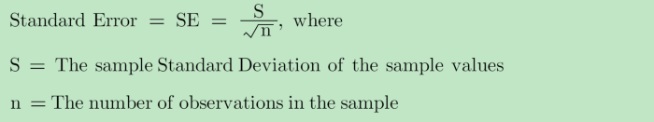

Image by author

**What are the examples of Standard Error?**

Standard Error can be applied to various types of ***statistics.***Some popular examples are

* The Standard Error of the Sample Mean (aka, the standard error of the mean, SEM)
* The Standard Error of the Sample Proportion (aka, the standard error of the proportion, SEP)

**What is the Standard Error of the Mean (SEM)?**

*The standard error of the mean (or simply standard error), indicates how different the****sample mean****is likely to be from the****population mean****.*

Technically, the standard error of the mean is computed as the standard deviation of the sample mean.

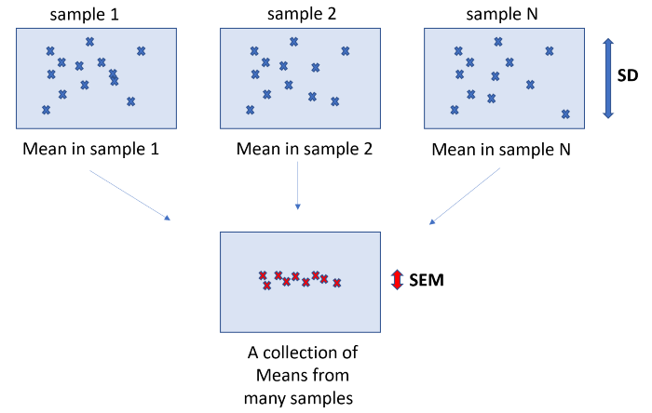

Image by author

Hypothetically, we can compute the standard error under repeated samples using the following steps:

1. Draw a new sample from the population.
2. Compute the sample mean of the drawn sample in Step 1
3. Repeat Steps 1 and 2 multiple times.
4. The standard error is obtained by computing the standard deviation of the previous steps’ sample means.

Thanks to **Central Limit Theorem (CLT)**, we don’t need to consider the Sampling Distribution under repeated samples. Instead, the sampling distribution of the sample means can be estimated from just ONE random sample.

*The Central Limit Theorem states that the sample mean has an approximately normal distribution with a****mean of μ****and a****standard deviation (or standard error) of σ/√n****.*

**How to derive the formula for SEM?**

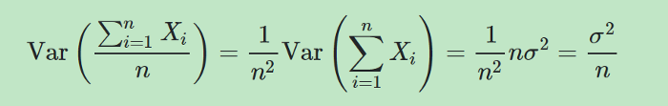

Image by author

Therefore,

https://miro.medium.com/max/700/1*NfvnvwybvskffXj5p-Jn7w.png

Image by author

In most cases, the standard deviation of the population data is unknown. We will estimate it using the standard deviation of the sample data (sample standard deviation).

Therefore,

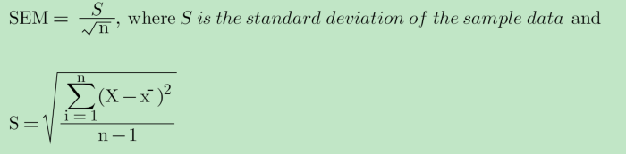

Image by author

**What is the Standard Error of the Proportion(SEP)?**

*The standard error of the proportion indicates how different the****sample proportion****is likely to be from the****population proportion****.*

The standard error of the proportion is computed as the standard deviation of the sample proportions.

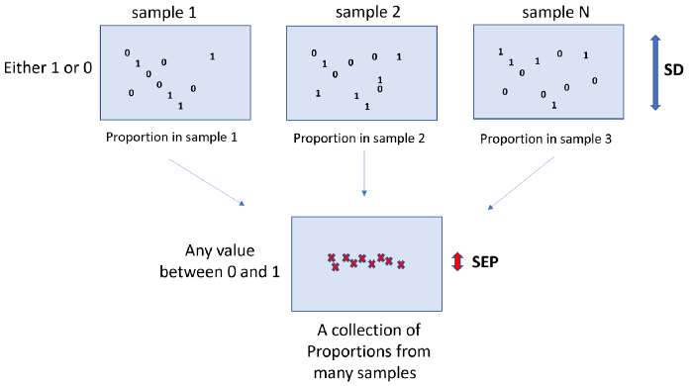

Image by author

You will notice that in each sample data, we only have data either 1 or 0. Each value follows a **Bernouilli distribution**. The computed sample proportions are no longer binary values. Instead, they could be any value between 0 and 1.

*The Central Limit Theorem states that the sample proportion has an approximately normal distribution with a****mean of p****and a****standard deviation (or standard error) of √P(1-P)/√n****, where P is the population proportion.*

**How to derive the formula for SEP?**

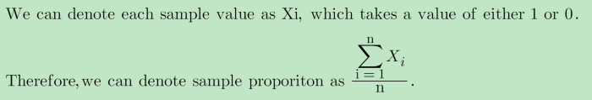

Image by author

Similar to SEM,



Image by author

https://miro.medium.com/max/700/1*oyj_7V73Bhh8W0YjZBwo0Q.png

Image by author

We can estimate **σ**using the sample standard deviation **√p(1-p)**(i.e., the standard deviation of a Bernouilli distribution)

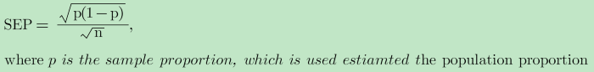

Image by author

**Conclusion:**

Standard Deviation and Standard Error are similar concepts that both are used to measure **variability.**

**Standard Deviation**indicates how the **sample data values** are different from the mean in the **sample distribution**.

**Standard Error**indicates how the **sample data statistics** are different from the population statistic in the **sampling distribution**.

If you would like to explore more posts related to **Statistics**, please check out my articles:

* [**7 Most Asked Questions on Central Limit Theorem**](https://towardsdatascience.com/7-most-asked-questions-on-central-limit-theorem-82e95eb7d964)
* [**Standard Deviation vs Standard Error: What’s the Difference?**](https://towardsdatascience.com/standard-deviation-vs-standard-error-whats-the-difference-ae969f48adef)
* [**3 Most Common Misinterpretations: Hypothesis Testing, Confidence Interval, P-Value**](https://towardsdatascience.com/the-most-common-misinterpretations-hypothesis-testing-confidence-interval-p-value-4548a10a5b72)
* [**Are the Error Terms Normally Distributed in a Linear Regression Model?**](https://towardsdatascience.com/are-the-error-terms-normally-distributed-in-a-linear-regression-model-15e6882298a4)
* [**Are the OLS Estimators Normally Distributed in a Linear Regression Model?**](https://towardsdatascience.com/are-ols-estimators-normally-distributed-in-a-linear-regression-model-89b688fa8dc3)
* [**What is Regularization: Bias-Variance Tradeoff**](https://towardsdatascience.com/machine-learning-bias-variance-tradeoff-and-regularization-94846f945131)

**Thank you for reading !!!**

If you enjoy this article and would like to **Buy Me a Coffee,**please [click here](https://ko-fi.com/aaronzhu).

You can sign up for a [**membership**](https://aaron-zhu.medium.com/membership)to unlock full access to my articles, and have unlimited access to everything on Medium. Please [**subscribe**](https://aaron-zhu.medium.com/subscribe)if you’d like to get an email notification whenever I post a new article.